CAS – Reflection Writing
A personal reflection is written by an individual to explore personal experiences, feelings and events. It is an opportunity to reconsider their perceptions and ideas from a different perspective. It encourages the learner to examine their experience and integrate specific learning opportunities that are beneficial to their personal growth. The goal is for the learner to describe their reaction and analyse their experiences in a more formal way than a diary or journal.

When creating a written reflection, try to organize your thoughts just like you would a paragraph or an essay, but in a more personal format than a formal research or analytical essay.
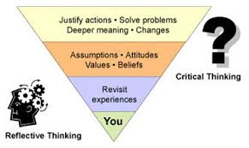
Everyone is different and therefore your reflections will also be different. Responses will be influenced by:
- Your personal opinions, beliefs and experiences
- Similarities or contrasts to your own life (i.e. experiences you can or cannot identify with)
- Sympathy/empathy with situations and or beings
- Your emotional state at the time of reflection
In your personal reflections you state your opinions, but in a manner that shows you have explored that opinion in a discerning manner showing you have considered it carefully from multiple perspectives (TOK).
You can do this by:
- Supporting your perspectives with examples
- Doubting or questioning any ideas or conclusions you might have initially made
- Create tentative conclusions about what you have taken away from the experience
- Posing questions for further consideration
This may sound a bit overwhelming to some, but relax - you cannot do all of this in every personal reflection. Once again though, the goal is to illustrate the depth of your learning and how this is encouraging personal growth. The reflection needs to be thorough enough for you and the reader(s) (Mrs. Hendren and Mrs. Quackenbush) to draw an accurate picture of your journey.
Please note:
Reflections do not simply summarize what you have done nor are they a run-on of ideas and thoughts.

